Name: Muskan Gupta

USN: 1BM19CS091

Setion: 3B

OOJ LAB OBSERVATION

LAB PROGRAM 1:

Develop a Java program that prints all real solutions to the quadratic equation ax2 +bx+c = 0.

Read in a, b, c and use the quadratic formula. If the discriminate b2-4ac is negative, display a message stating that there are no real solutions.

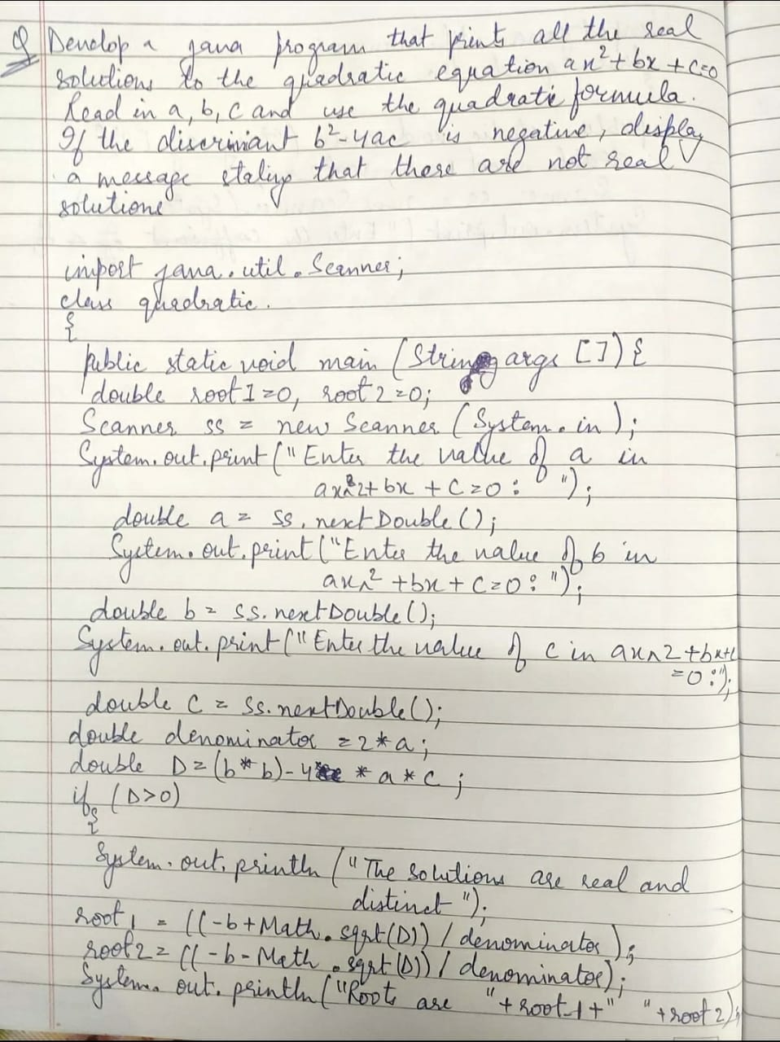

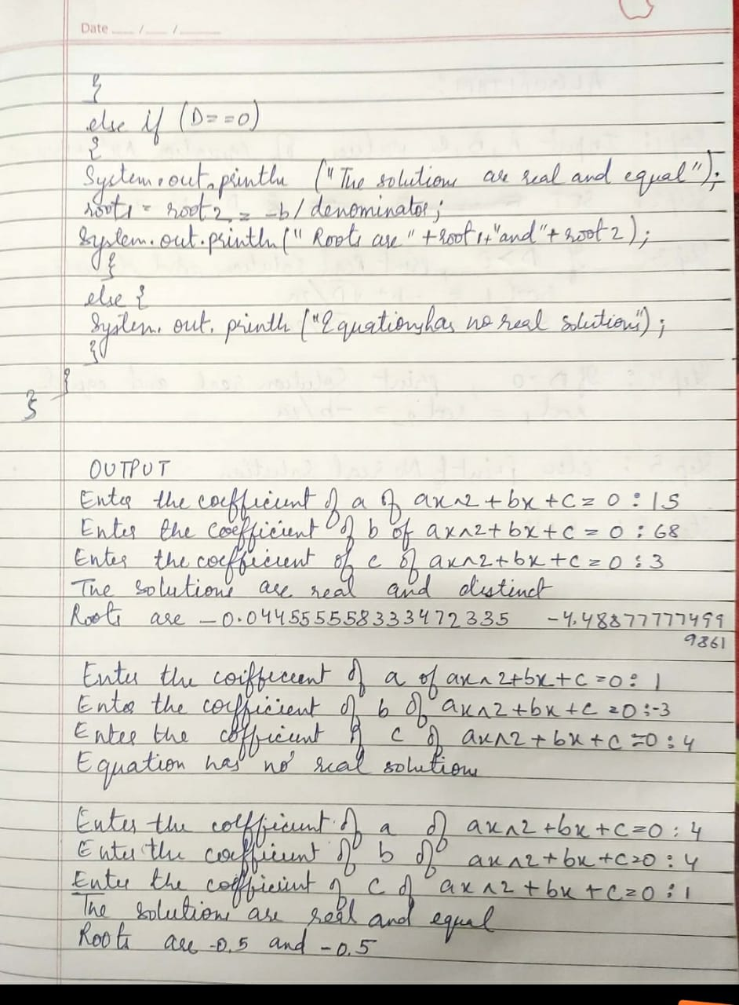

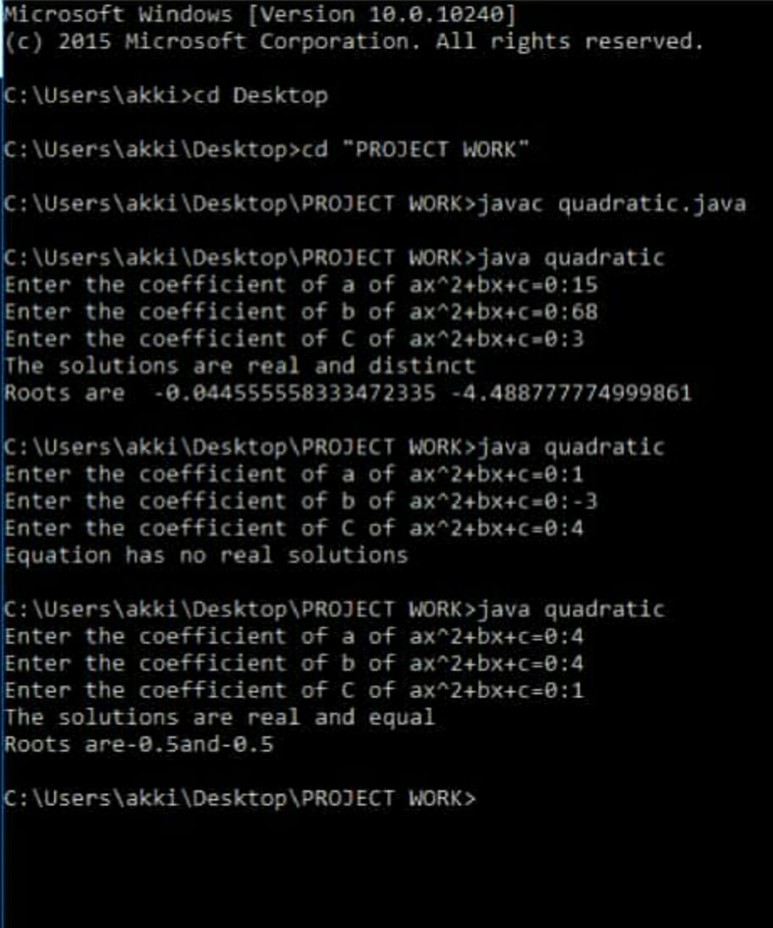

LAB PROGRAM 2:

Develop a Java program to create a class Student with members usn, name, an array

credits and an array marks. Include methods to accept and display details and a method to

calculate SGPA of a student.

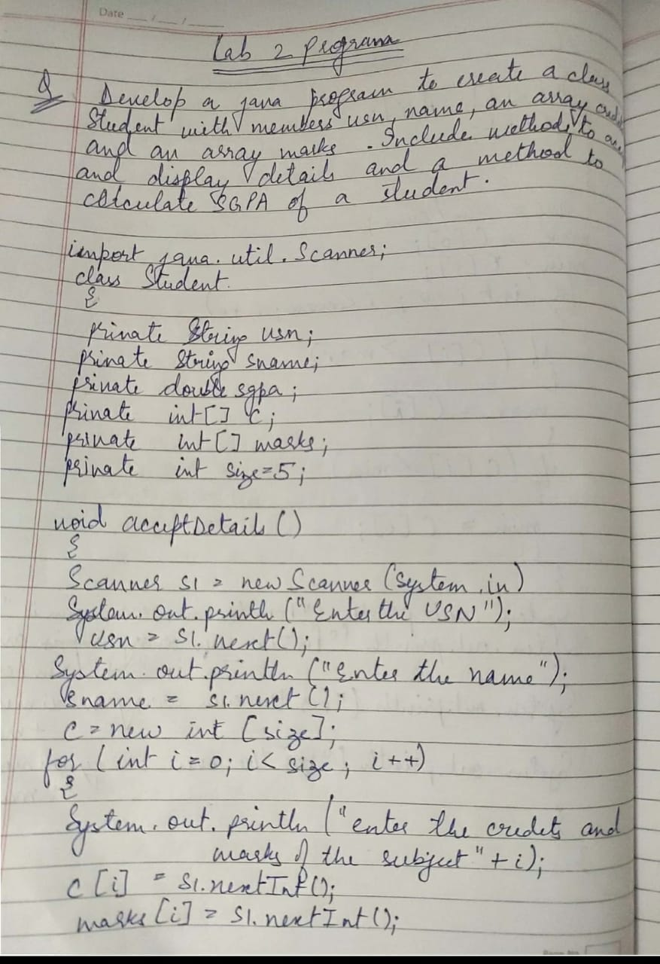

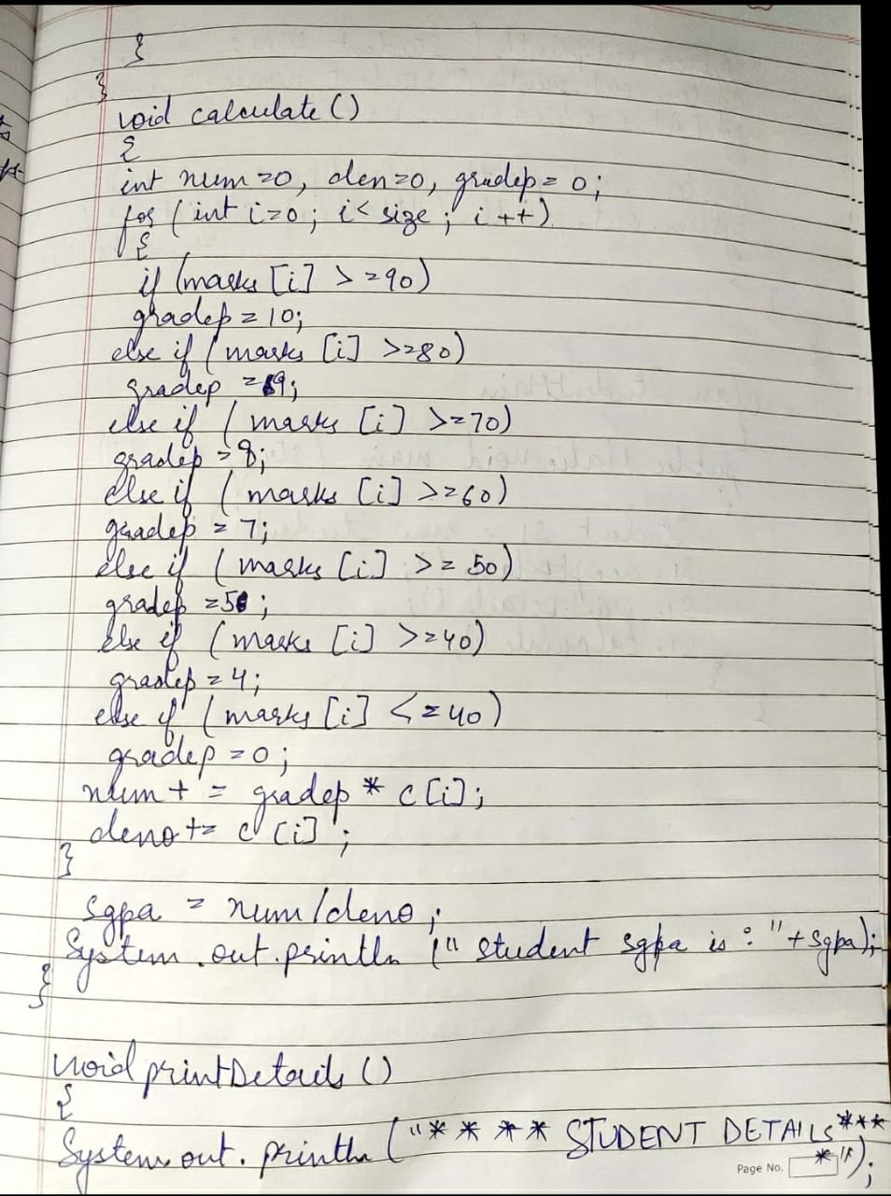

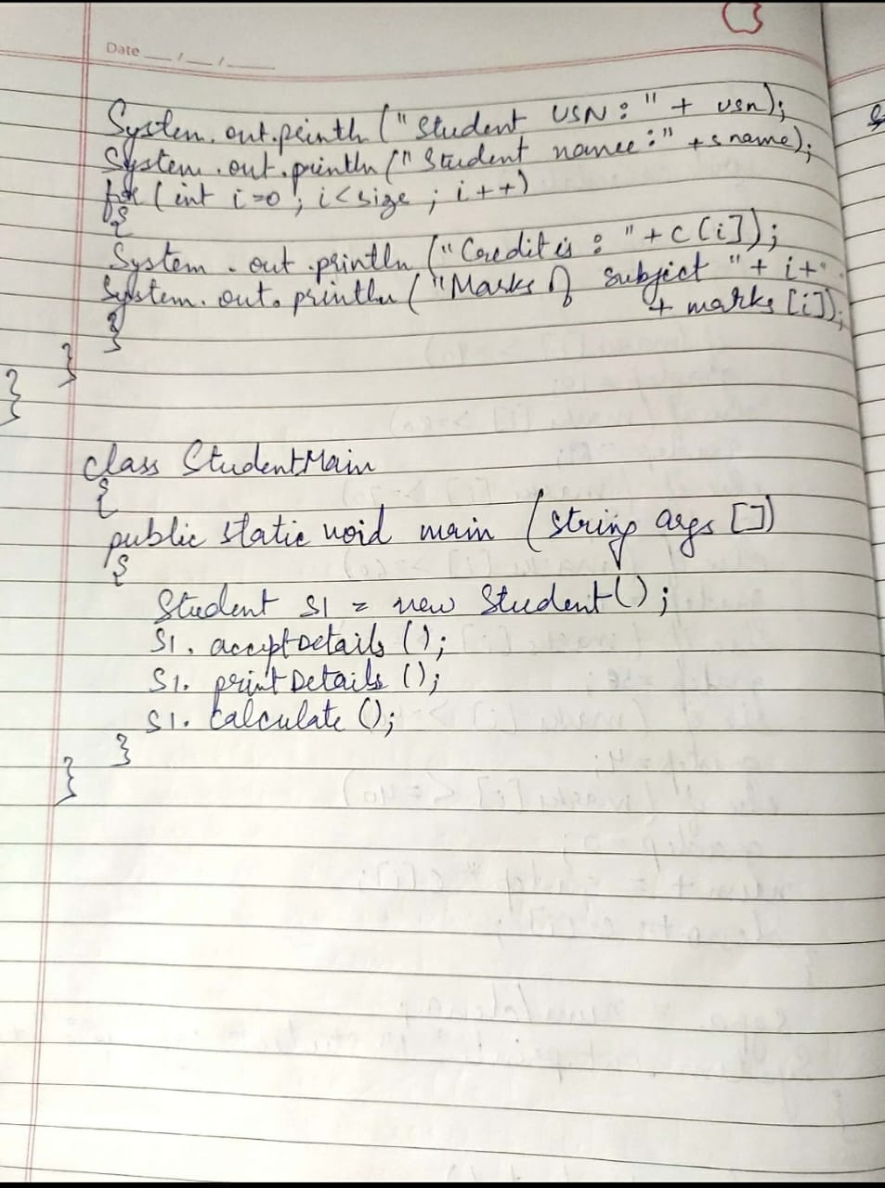

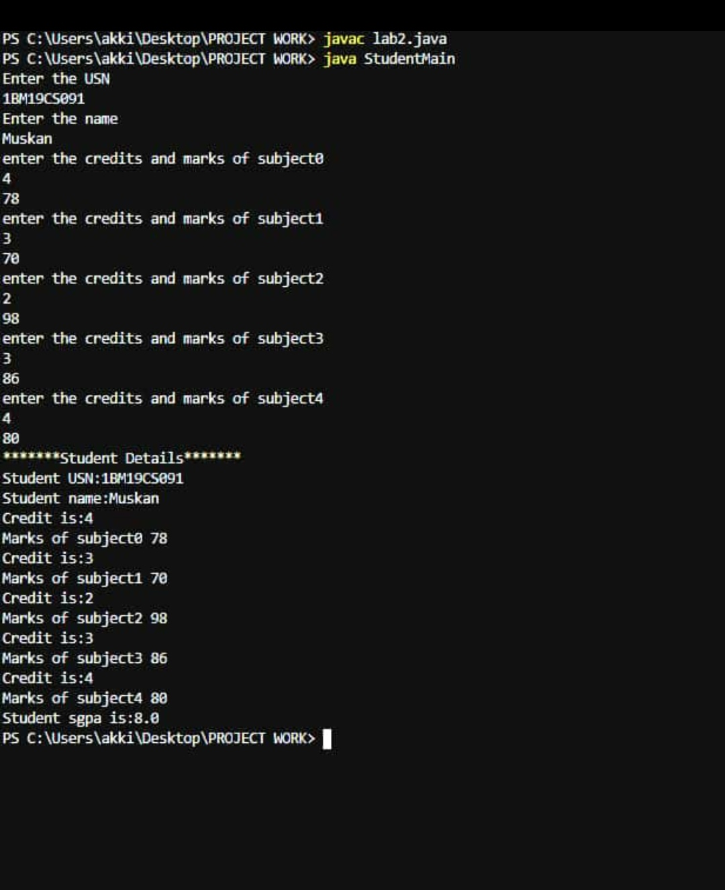

LAB PROGRAM 3:

Create a class Book which contains four members: name, author, price,

num_pages. Include a constructor to set the values for the members. Include

methods to set and get the details of the objects. Include a toString( ) method

that could display the complete details of the book. Develop a Java program to

create a book object.

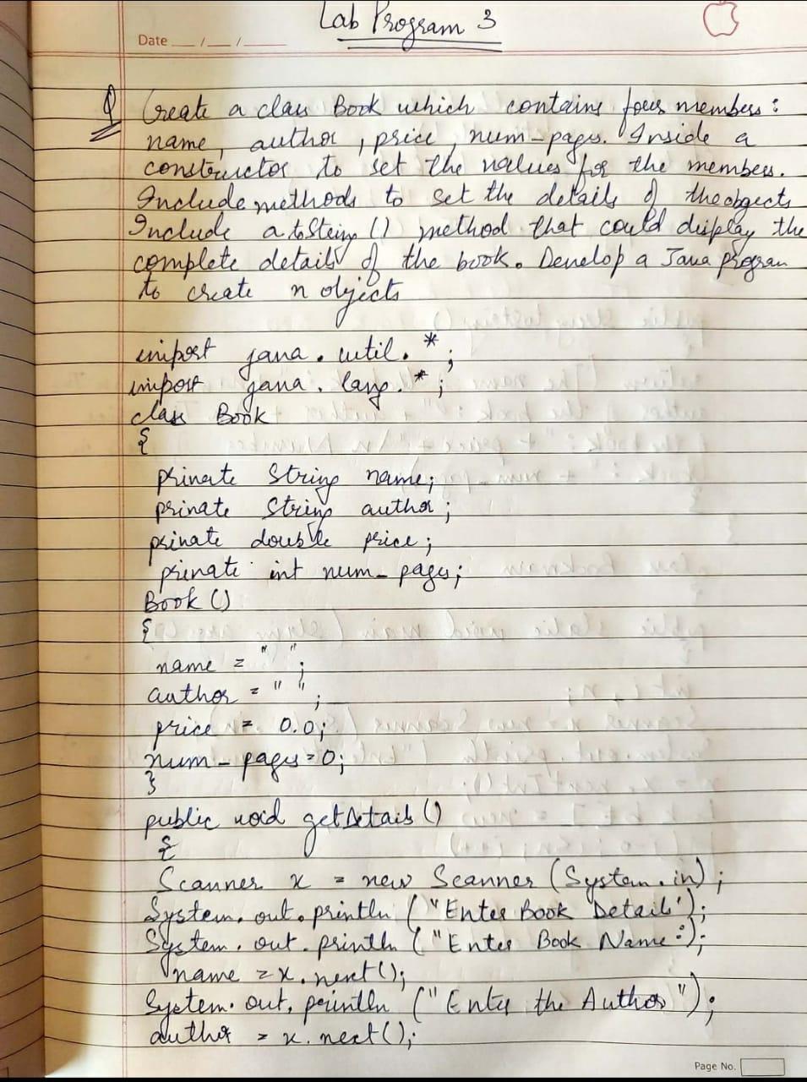

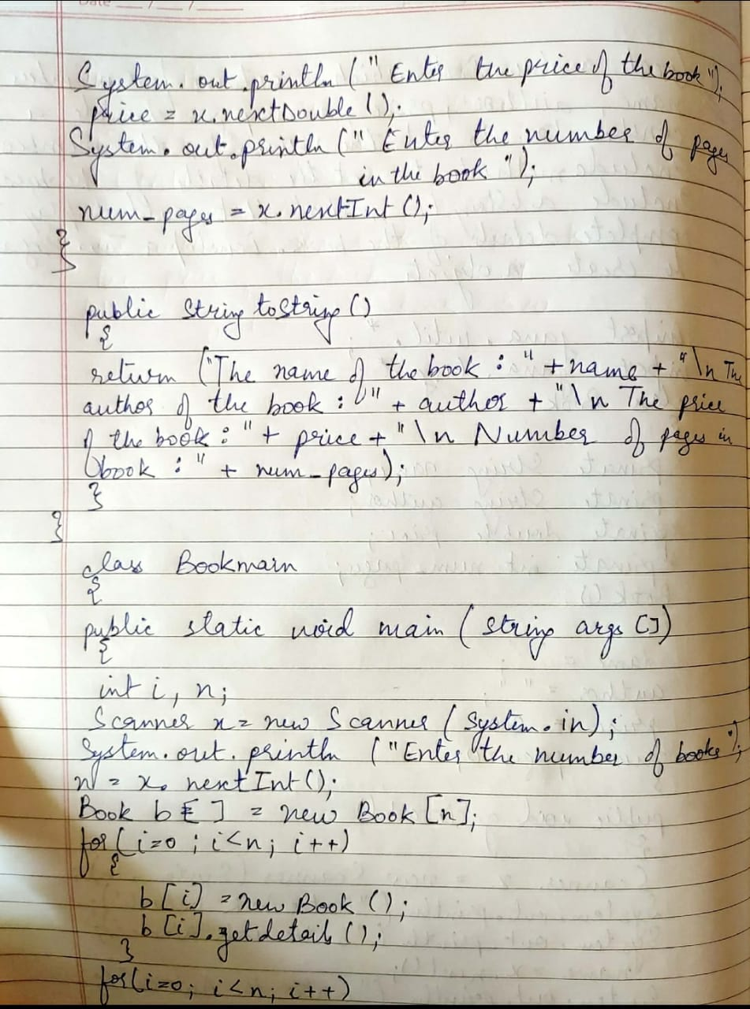

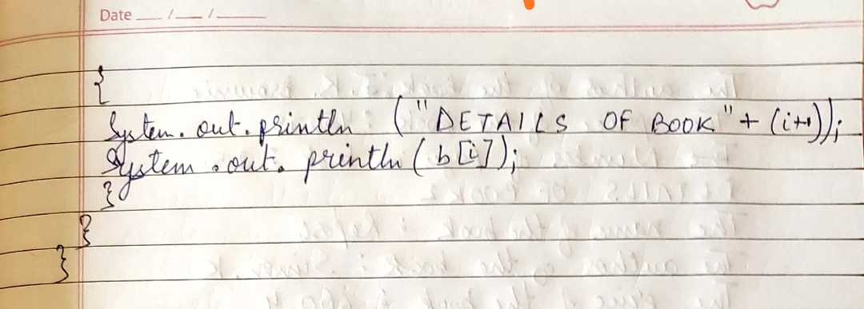

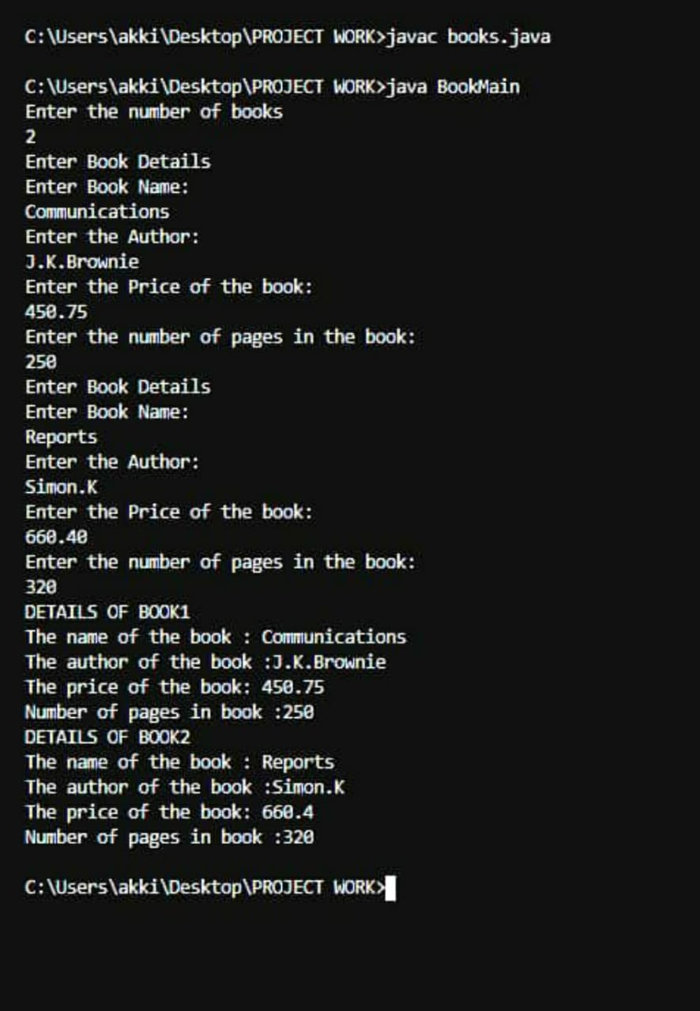

LAB PROGRAM 4:

Develop a Java program to create an abstract class named Shape that contains two integers and

an empty method named printArea( ). Provide three classes named Rectangle, Triangle and

Circle such that each one of the classes extends the class Shape. Each one of the classes contain

only the method printArea( ) that prints the area of the given shape.

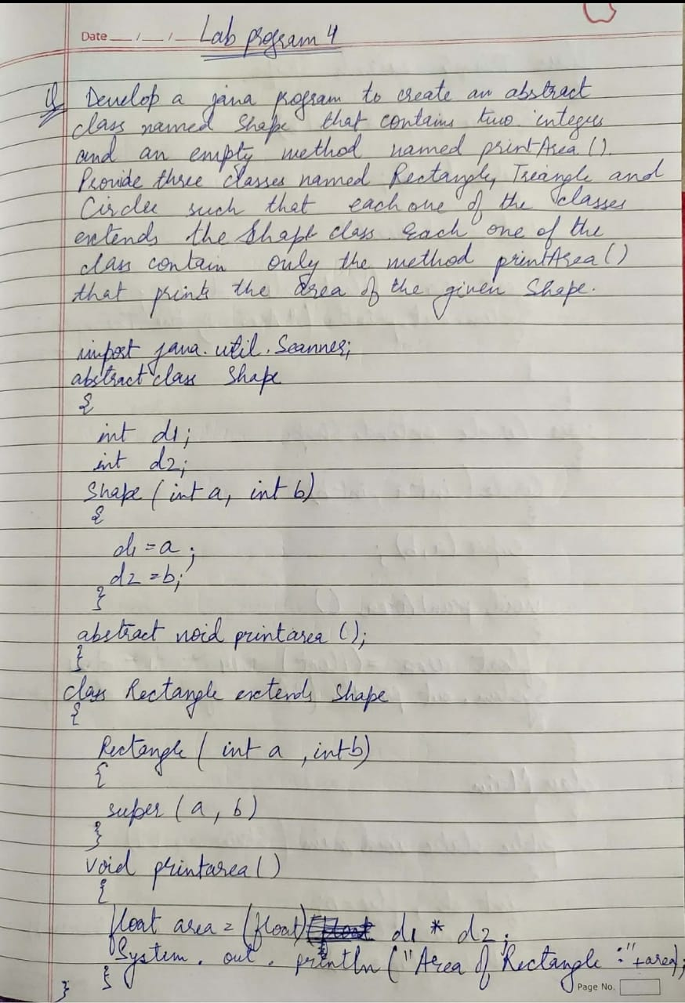

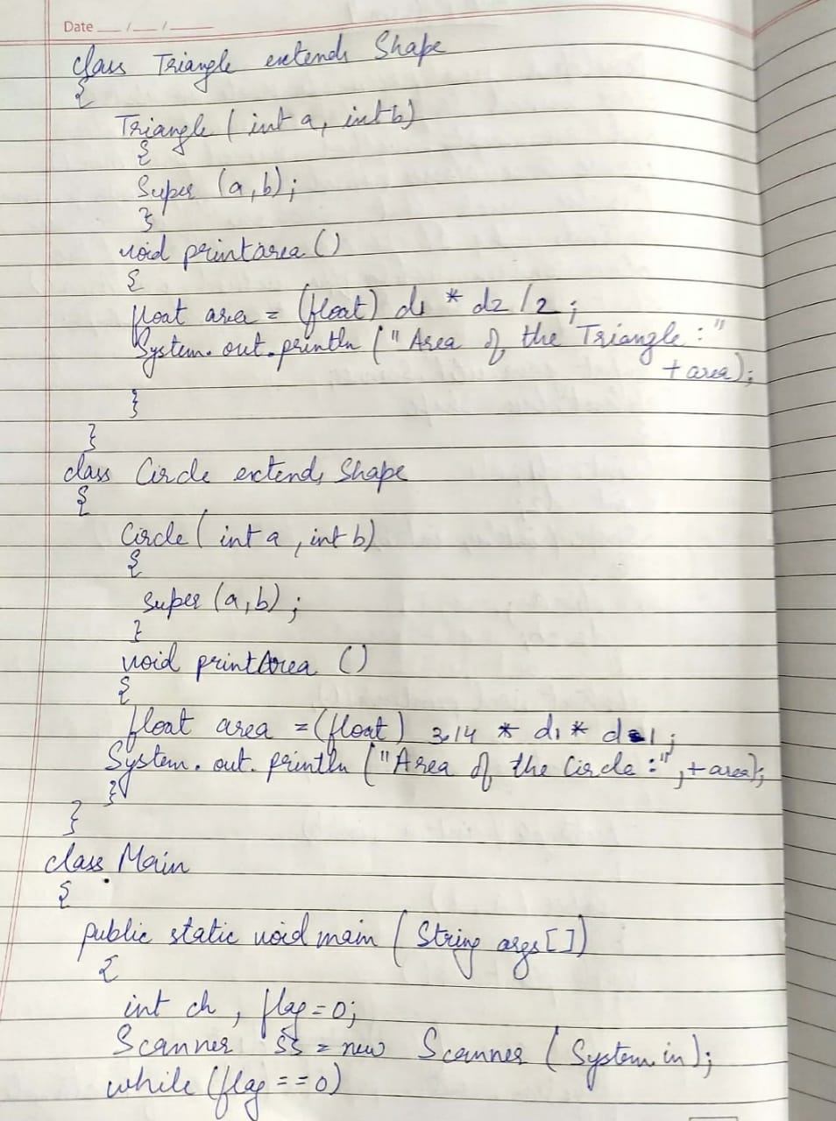

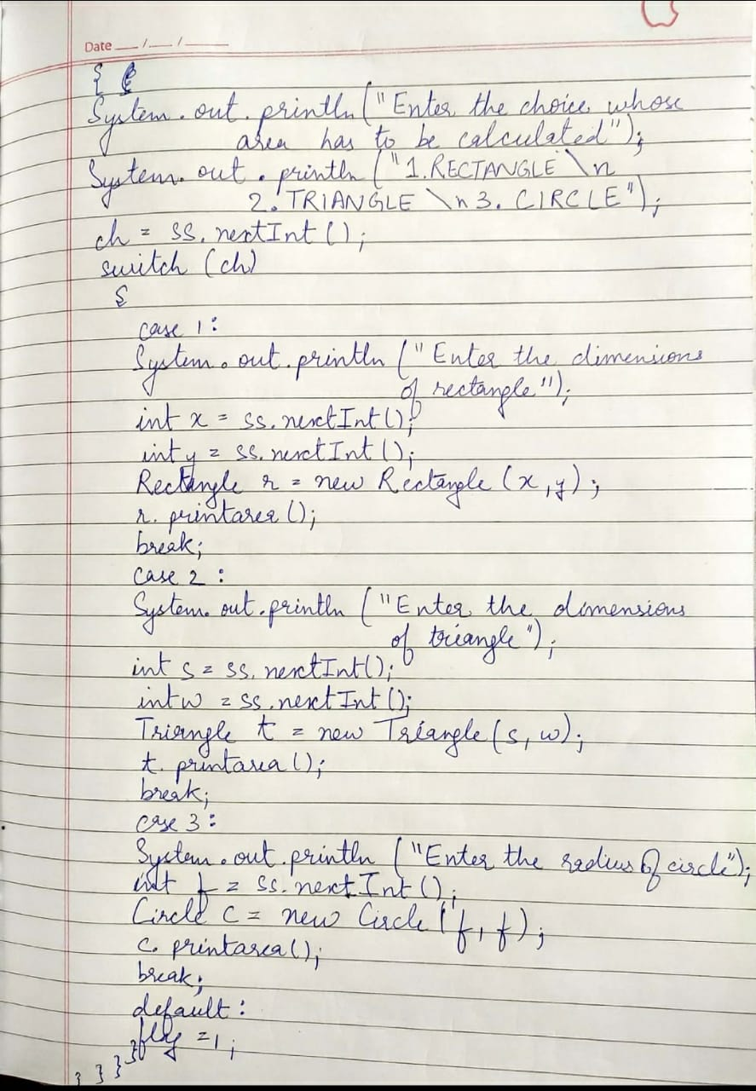

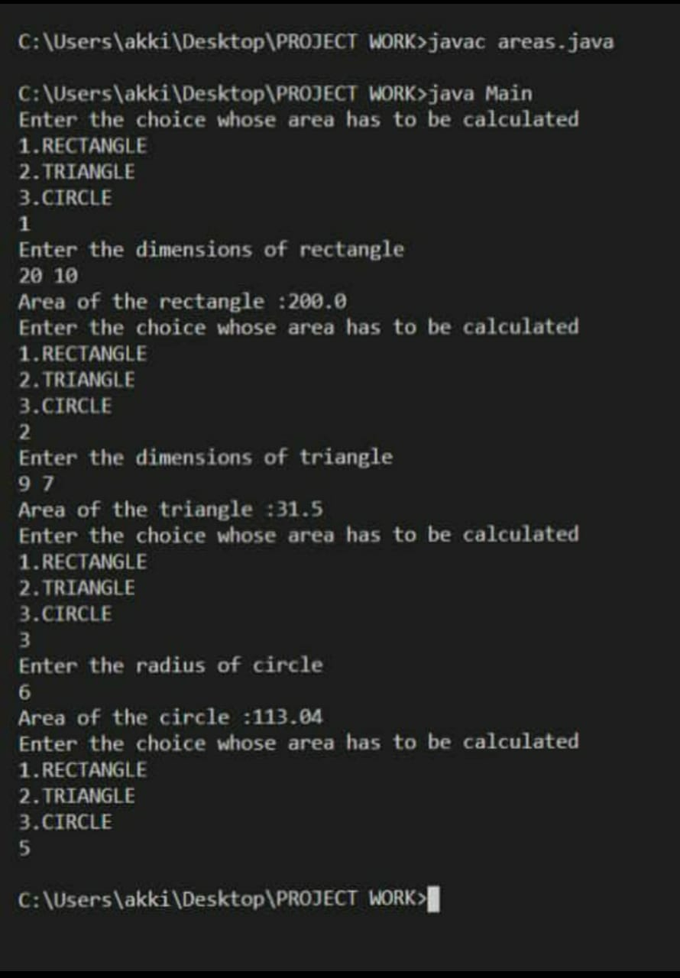

LAB PROGRAM 5:

Develop a Java program to create a class Bank that maintains two kinds of account for its

customers, one called savings account and the other current account. The savings account

provides compound interest and withdrawal facilities but no cheque book facility. The current

account provides cheque book facility but no interest. Current account holders should also

maintain a minimum balance and if the balance falls below this level, a service charge is

imposed. Create a class Account that stores customer name, account number and type of

account. From this derive the classes Curr-acct and Sav-acct to make them more specific to

their requirements. Include the necessary methods in order to achieve the following tasks: •

Accept deposit from customer and update the balance. • Display the balance. • Compute and

deposit interest • Permit withdrawal and update the balance • Check for the minimum balance,

impose penalty if necessary and update the balance.

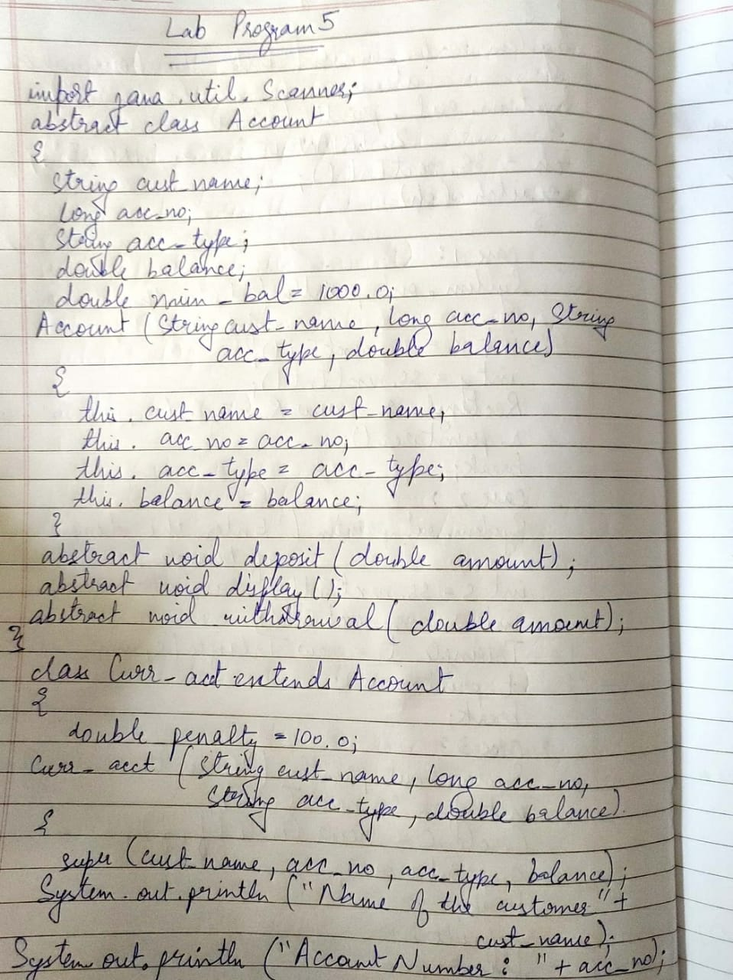

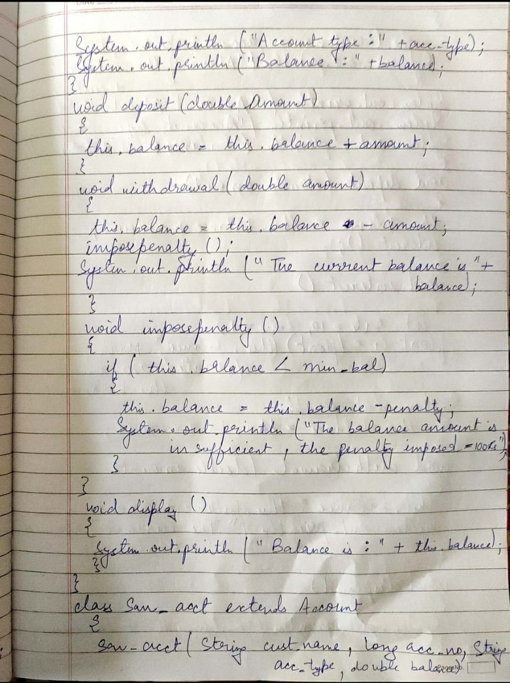

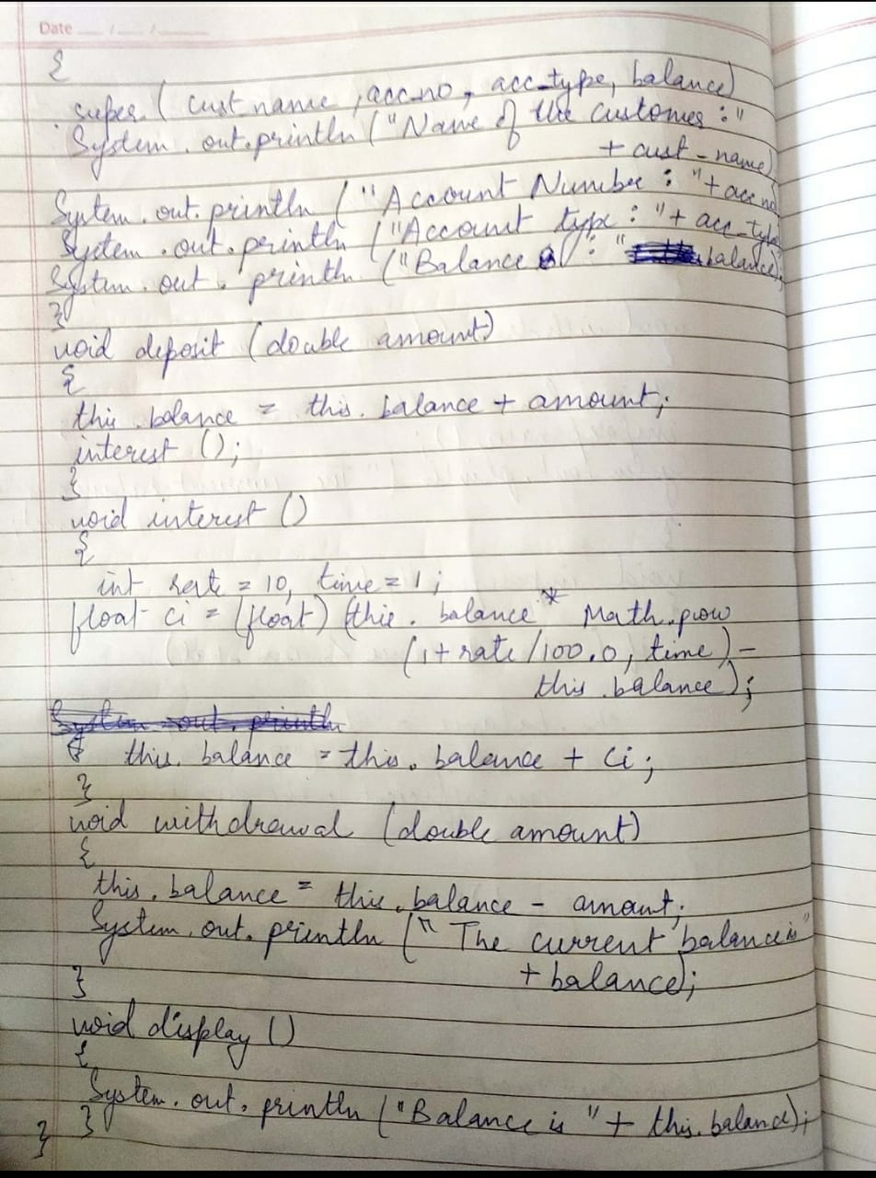

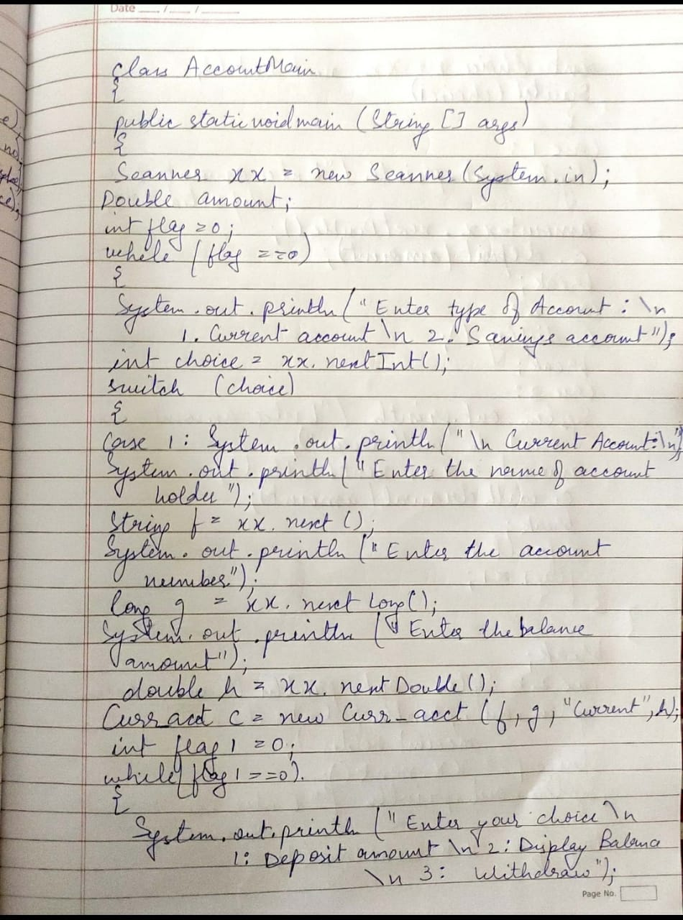

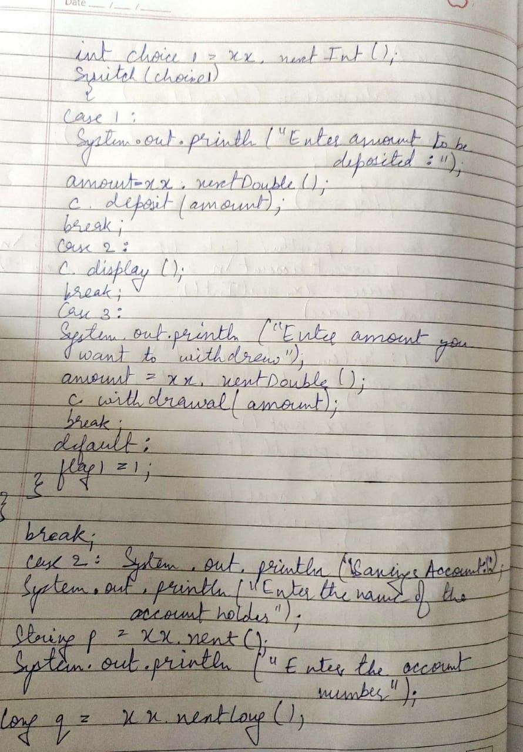

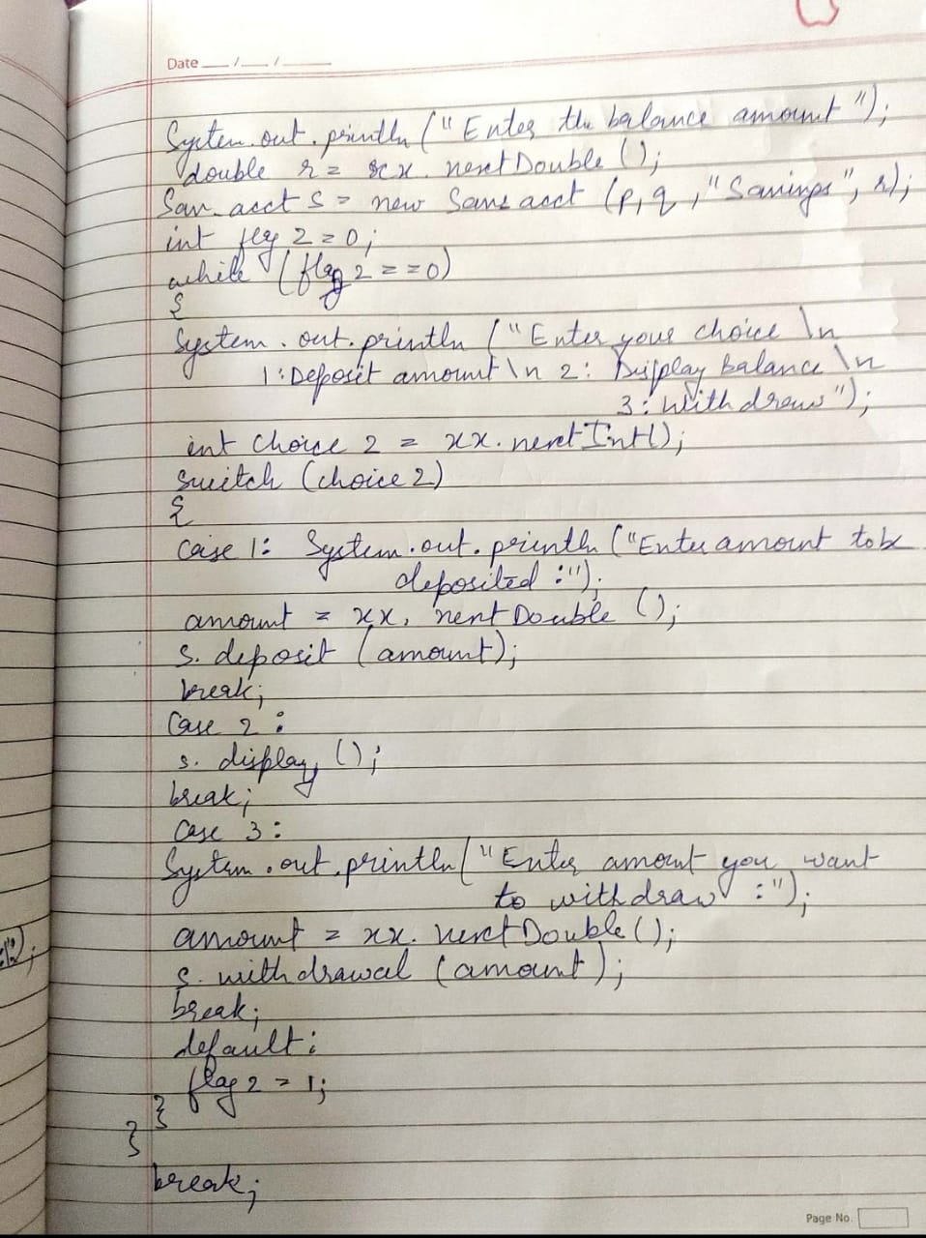

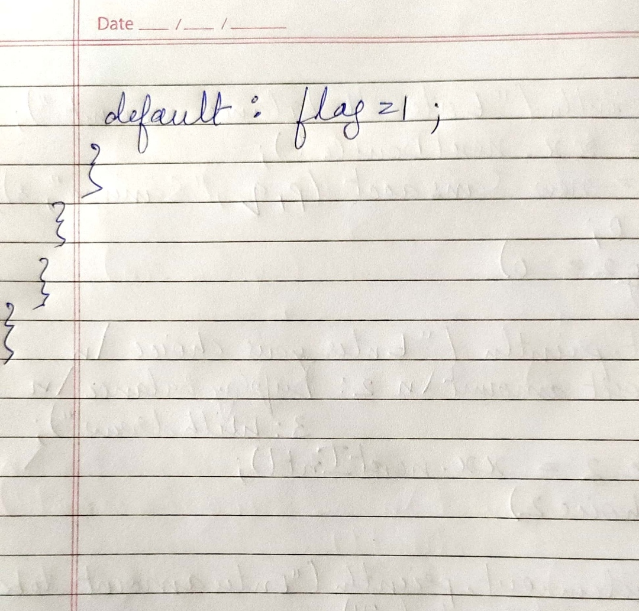

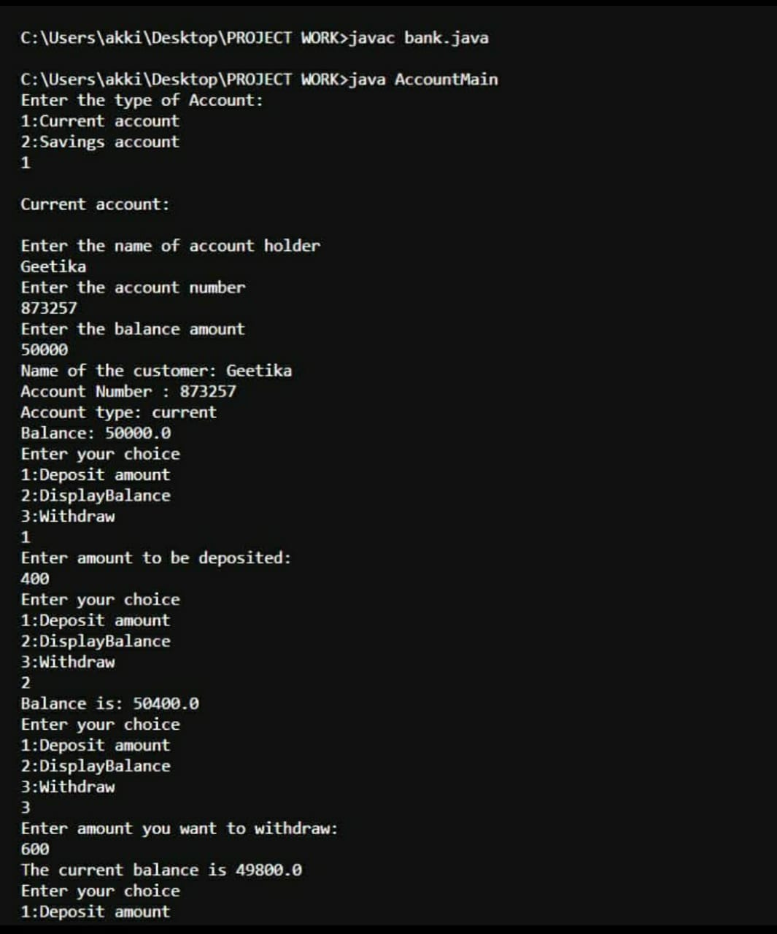

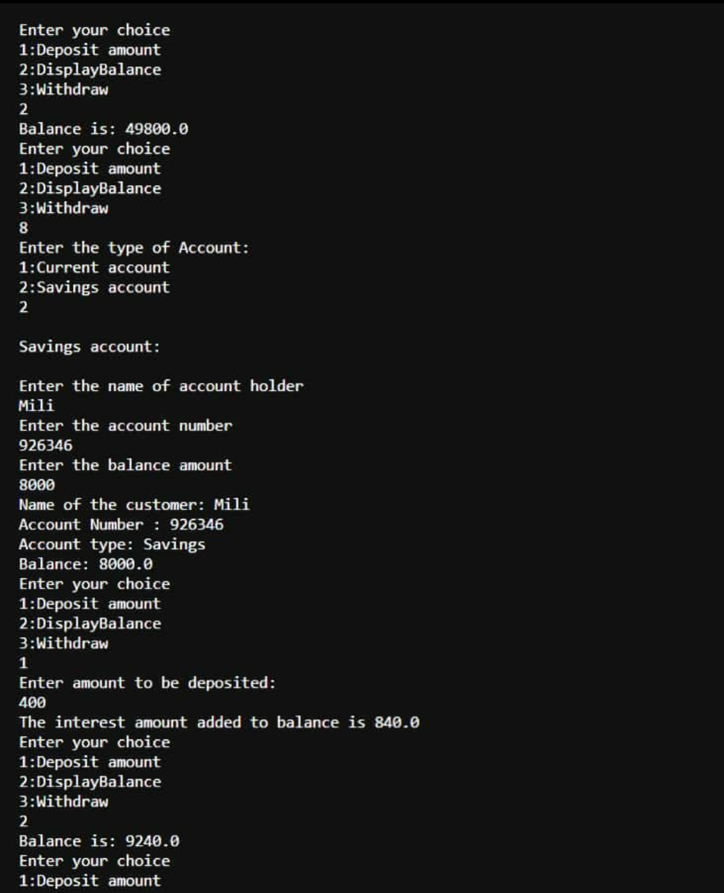

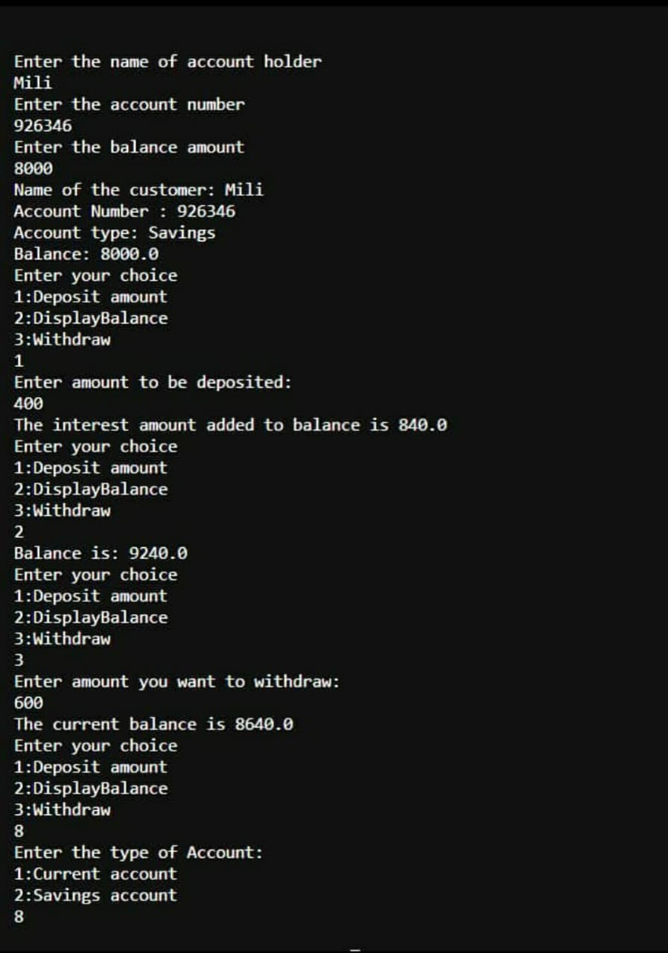

LAB PROGRAM 6:

Create a package CIE which has two classes- Student and Internals. The

class Personal has members like usn, name, sem. The class Internals has an

array that stores the internal marks scored in five courses of the current

semester of the student. Create another package SEE which has the class

External which is a derived class of Student. This class has an array that

stores the SEE marks scored in five courses of the current semester of the

student. Import the two packages in a file that declares the final marks of n

students in all five courses.

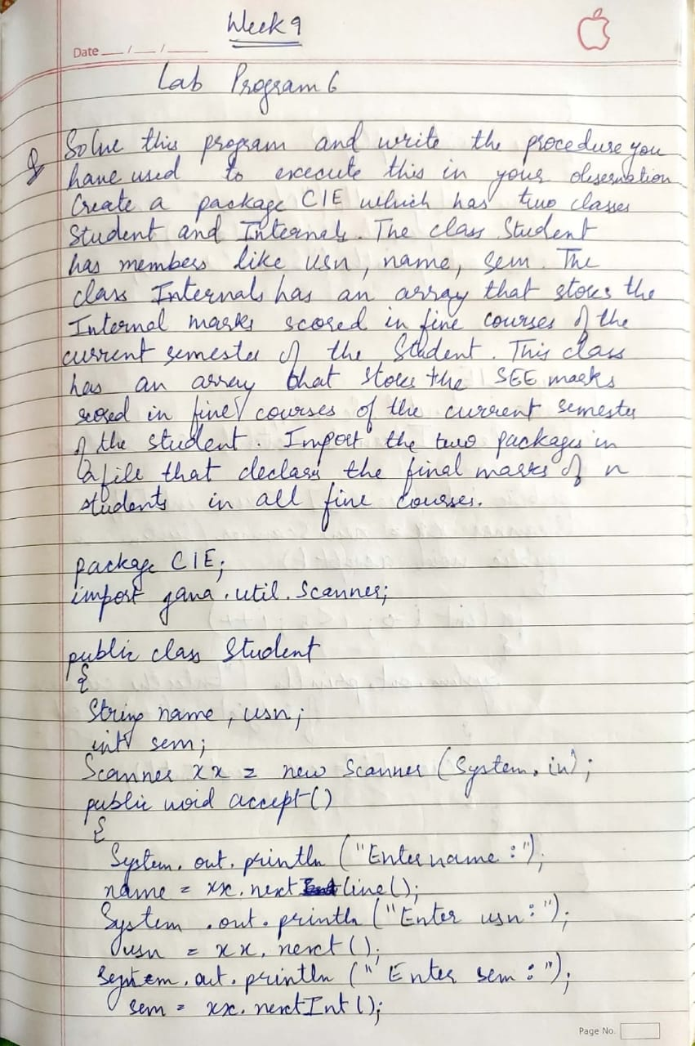

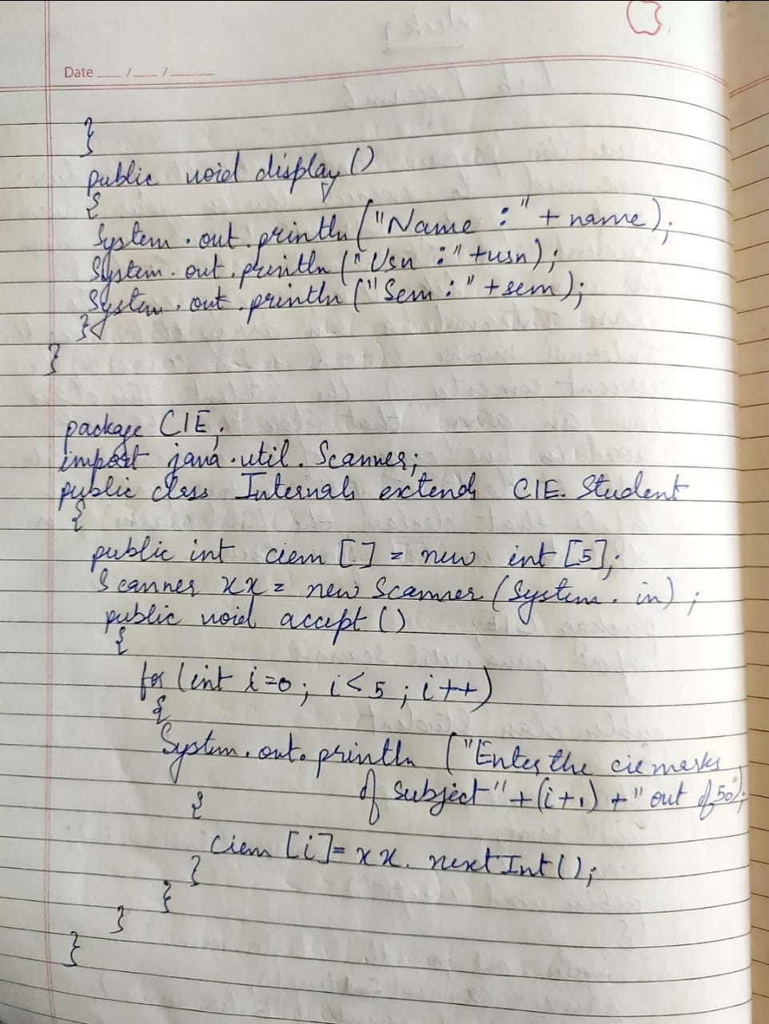

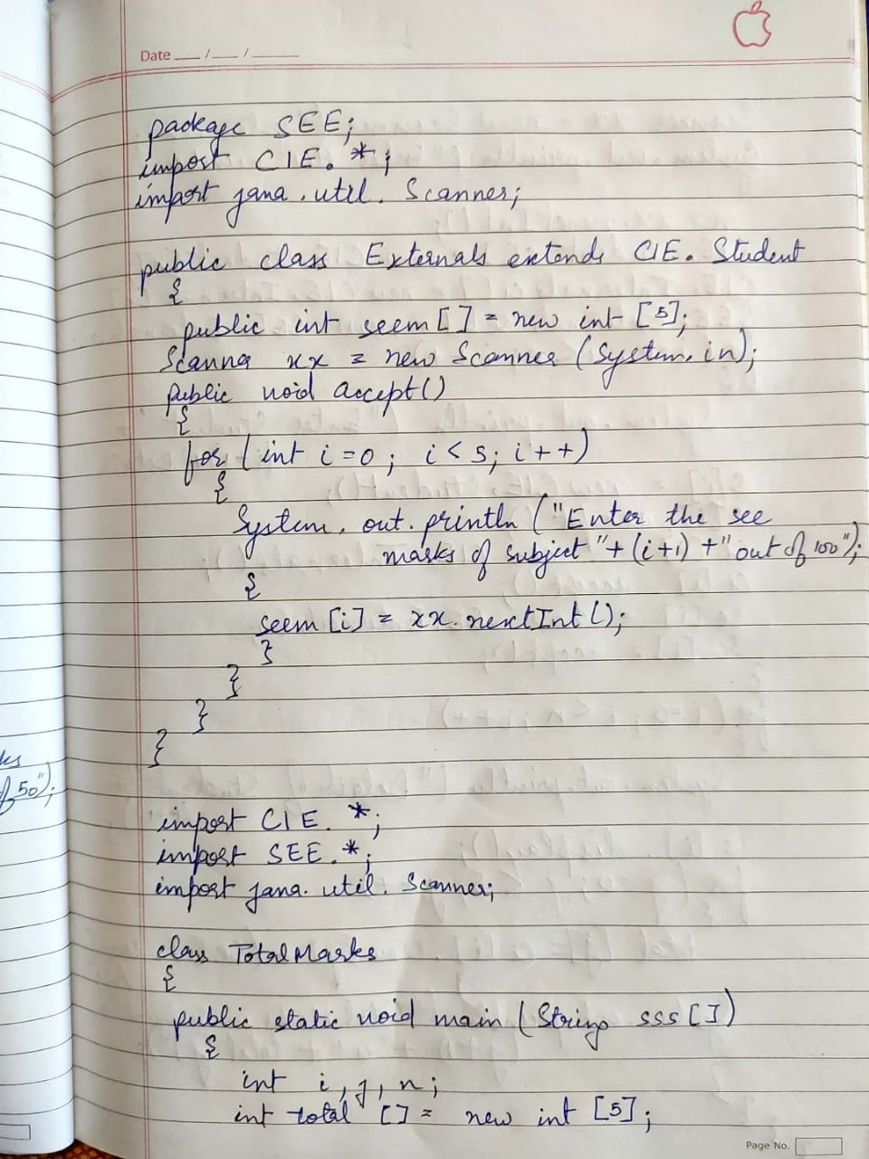

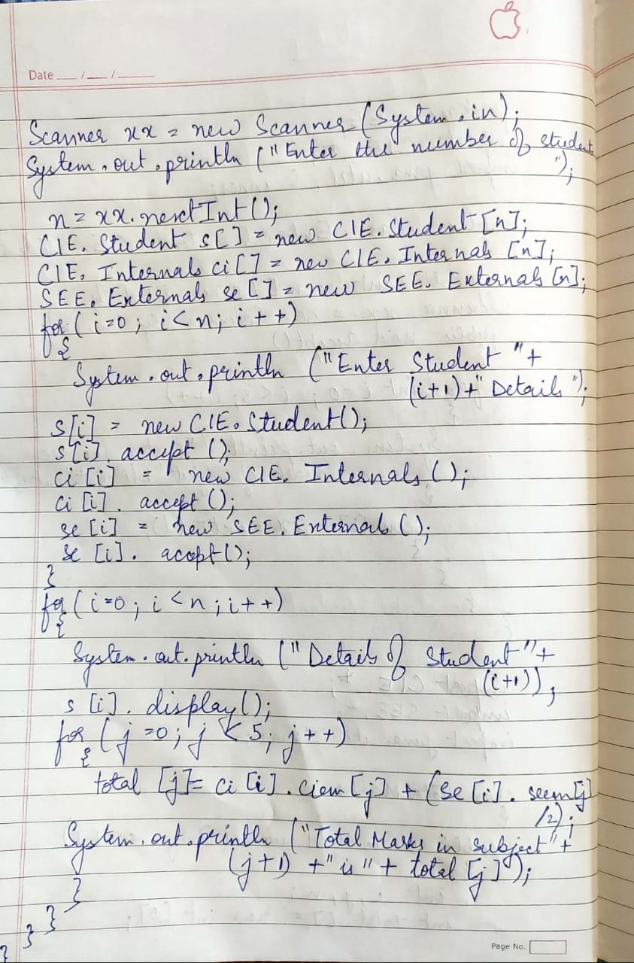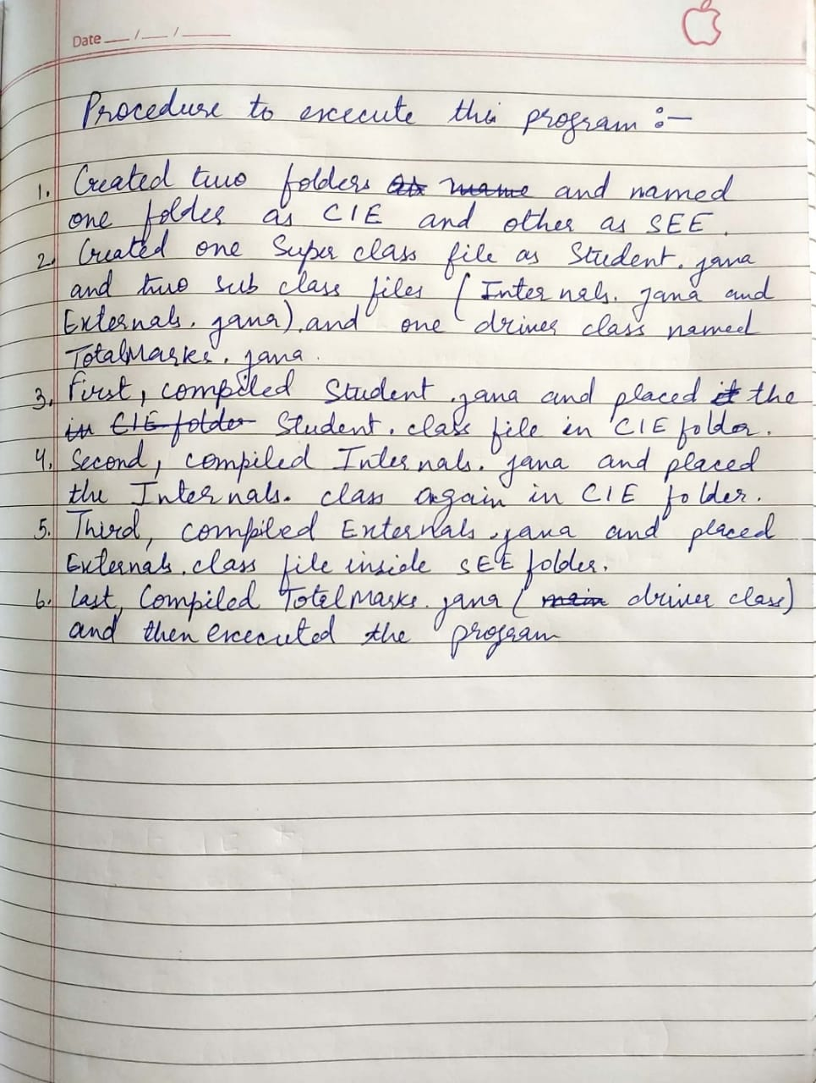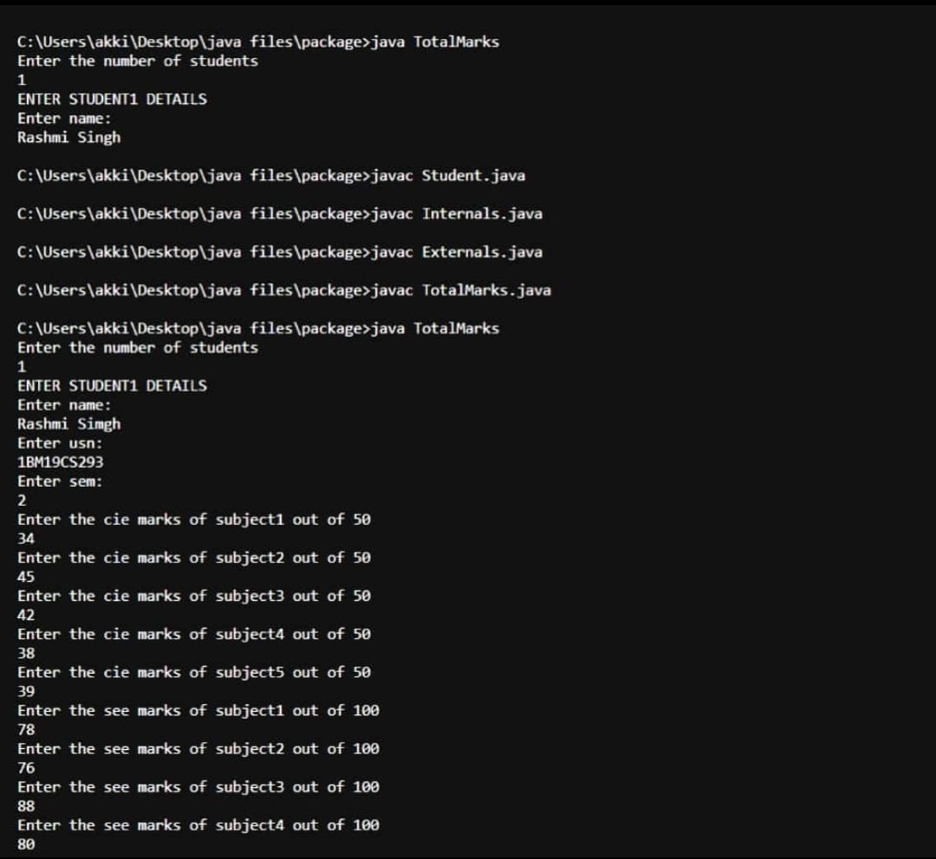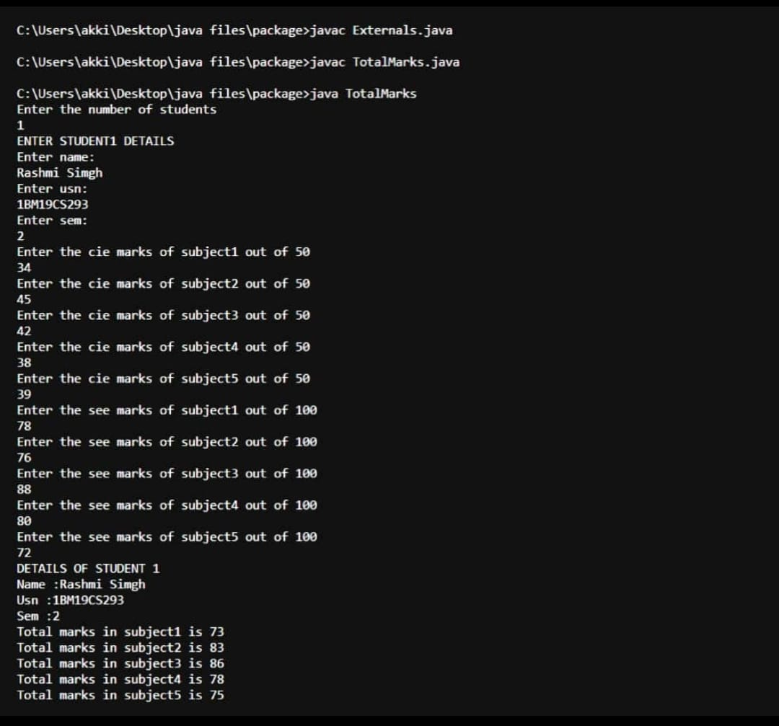

LAB PROGRAM 7 : Write a program to demonstrate generics with multiple object parameters.

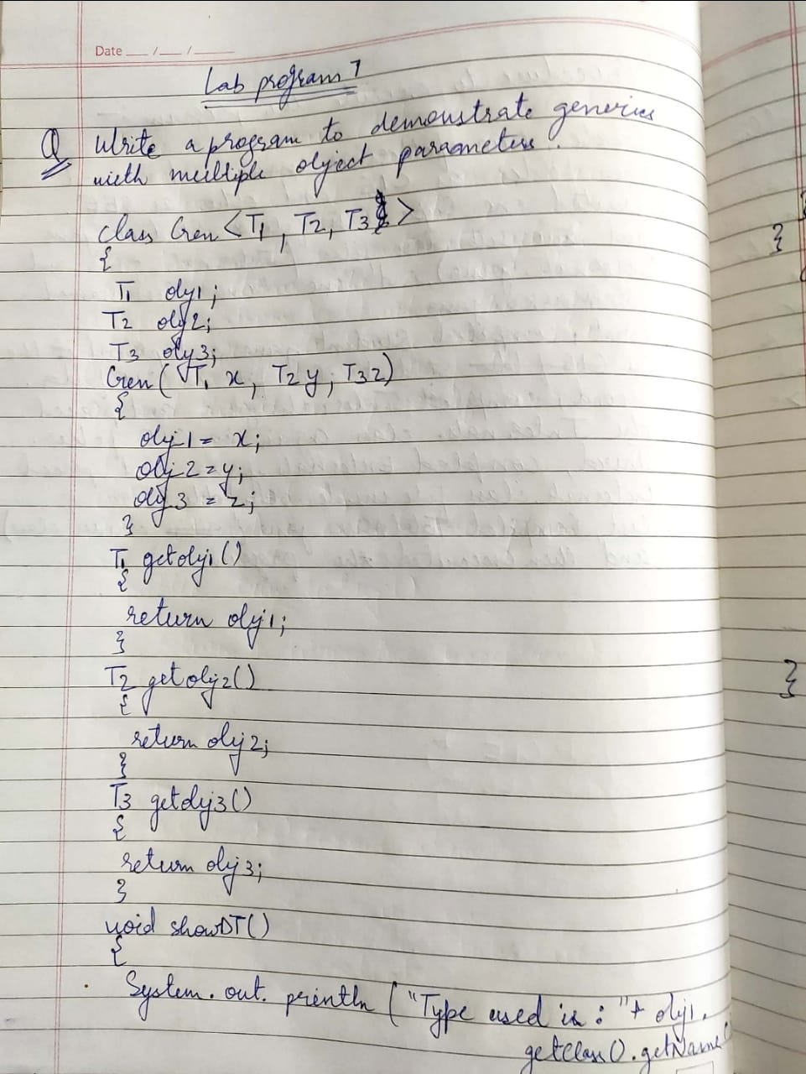

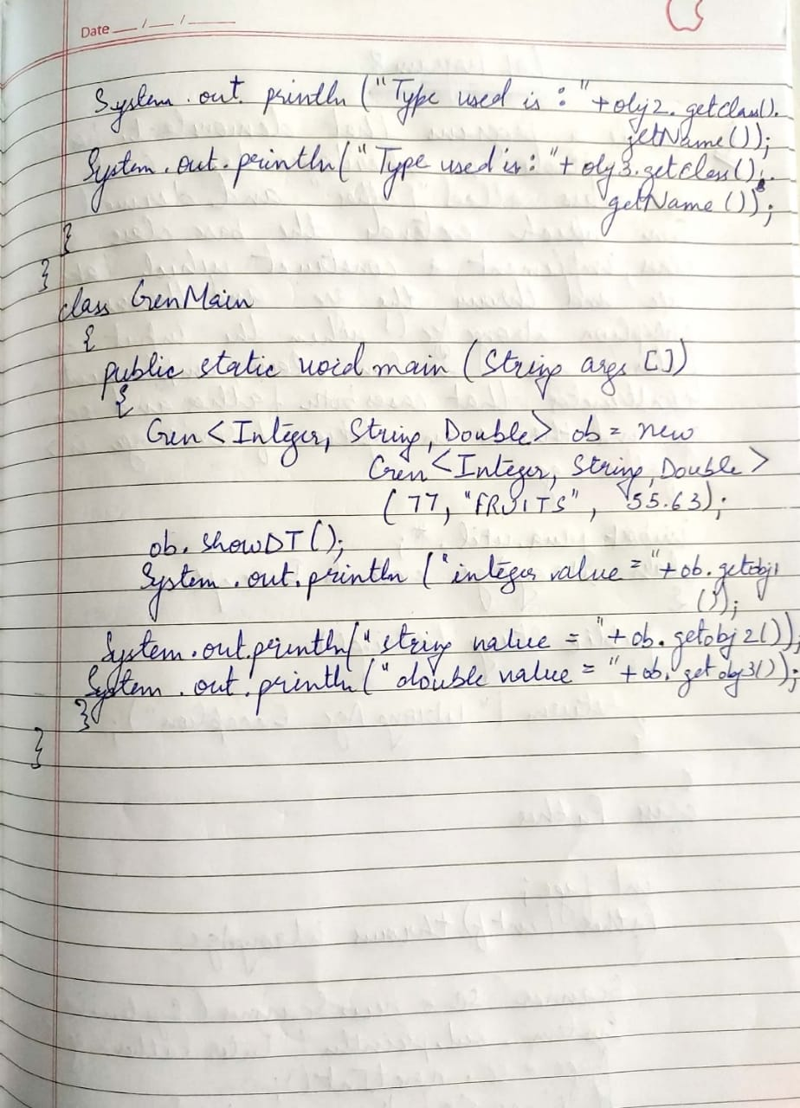

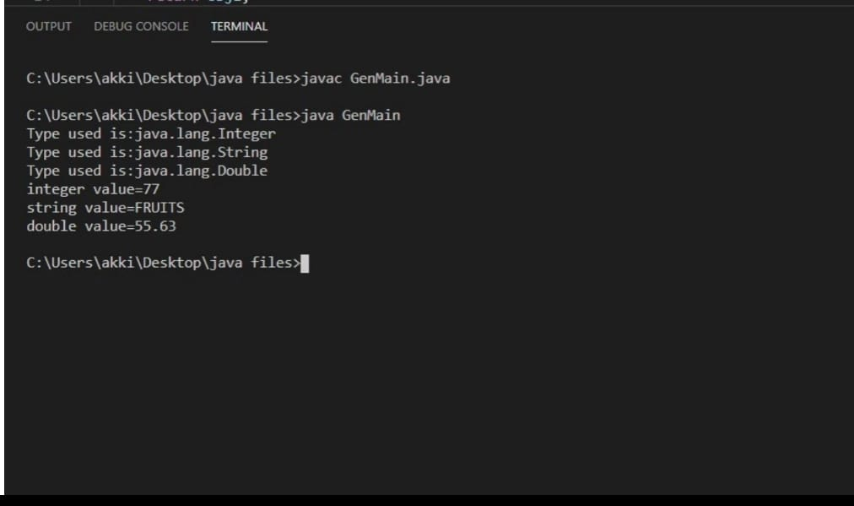

LAB PROGRAM 8: Write a program that demonstrates handling of exceptions in inheritance tree. Create a base class called “Father” and derived class called “Son” which extends the base class. In Father class, implement a constructor which takes the age and throws the exception Wrong Age( ) when the input age<0. In Son class, implement a constructor that cases both father and son’s age and throws an exception if son’s age is >=father’s age.

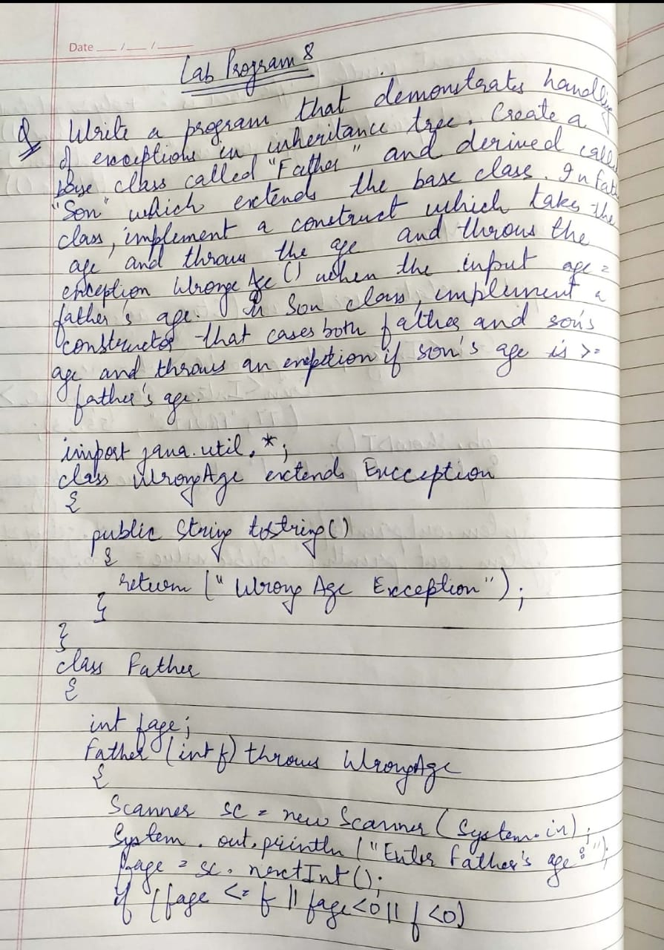

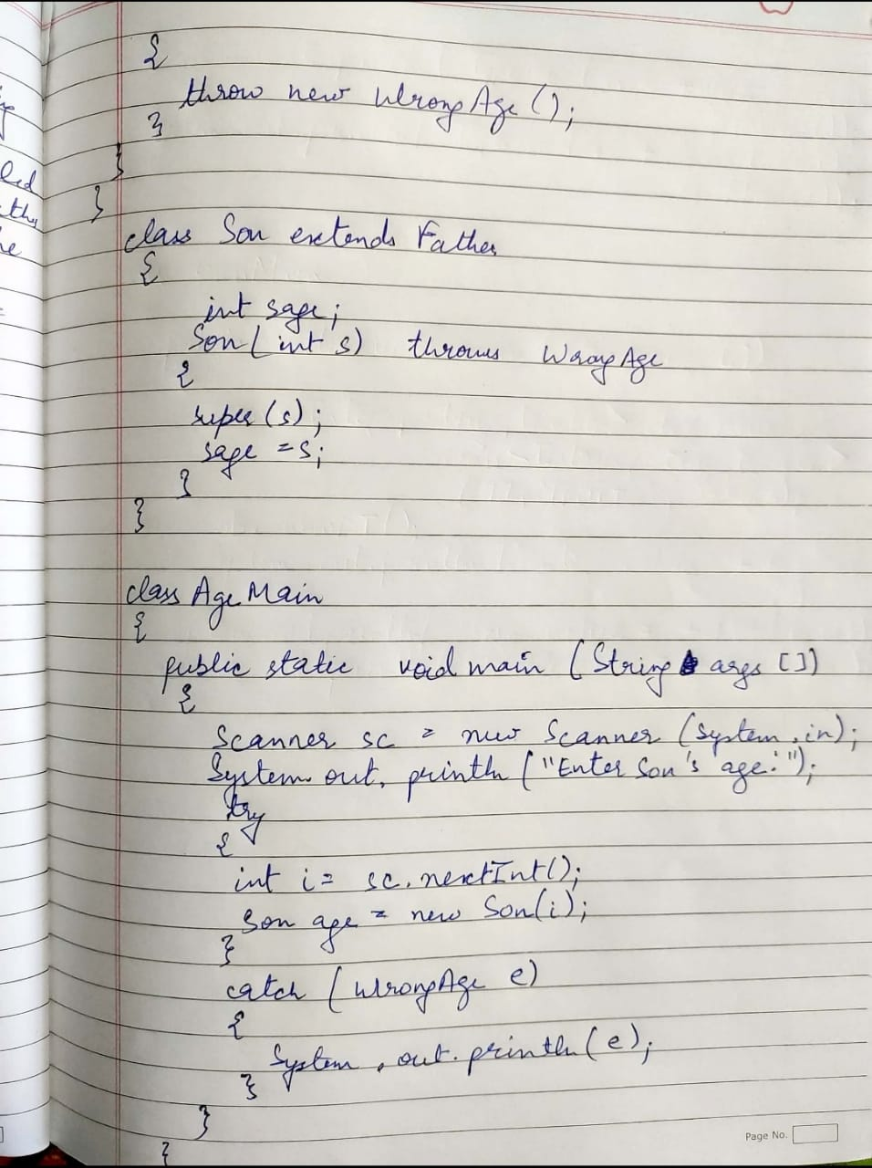

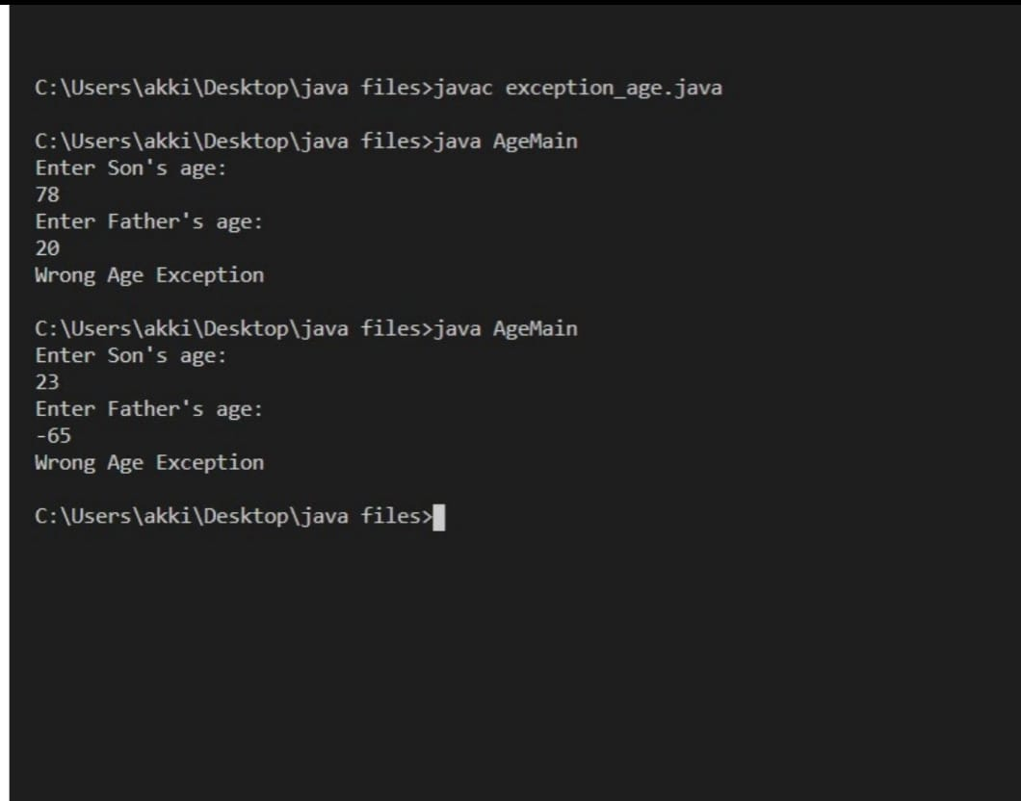

LAB PROGRAM 9: Write a program which creates two threads, one thread displaying “BMS College of Engineering” once every ten seconds and another displaying “CSE” once every two seconds.

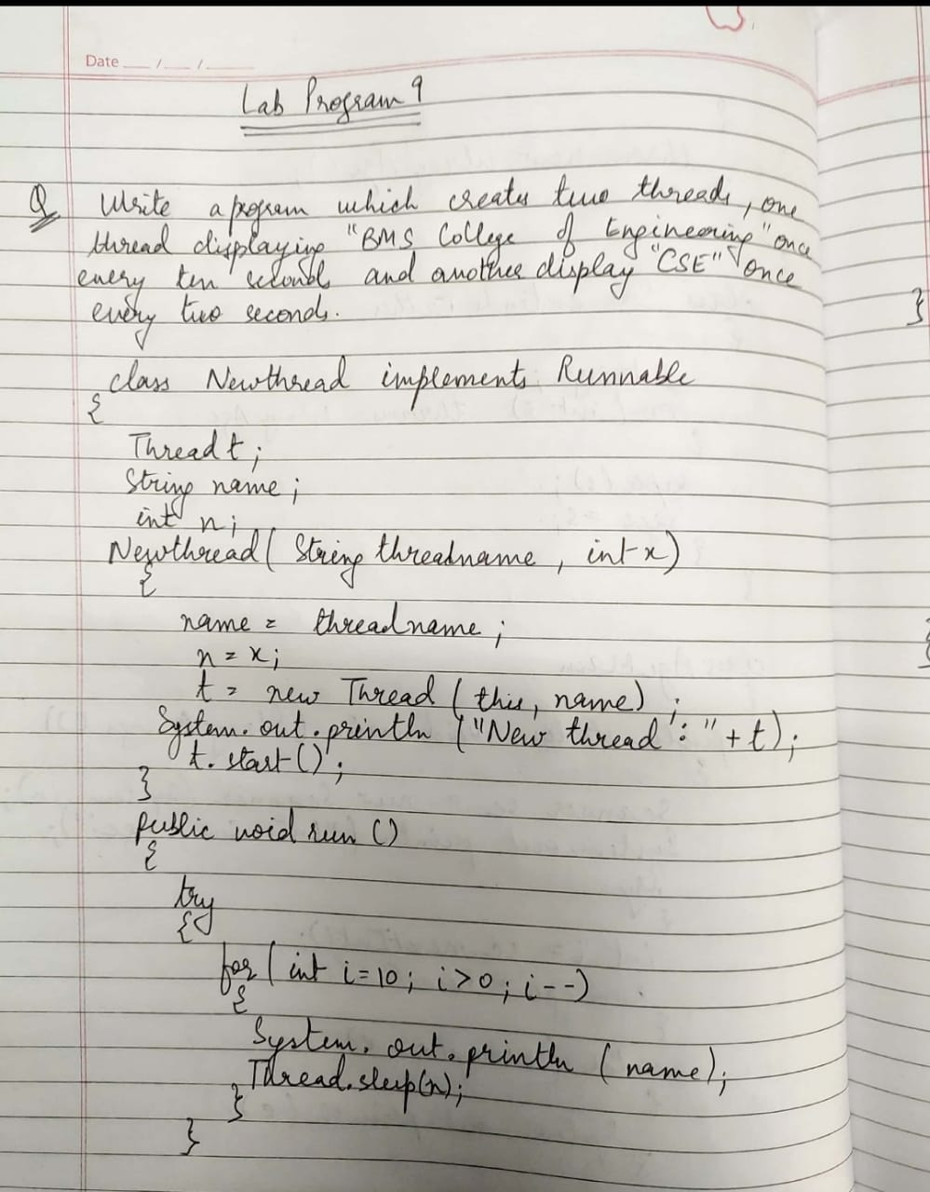

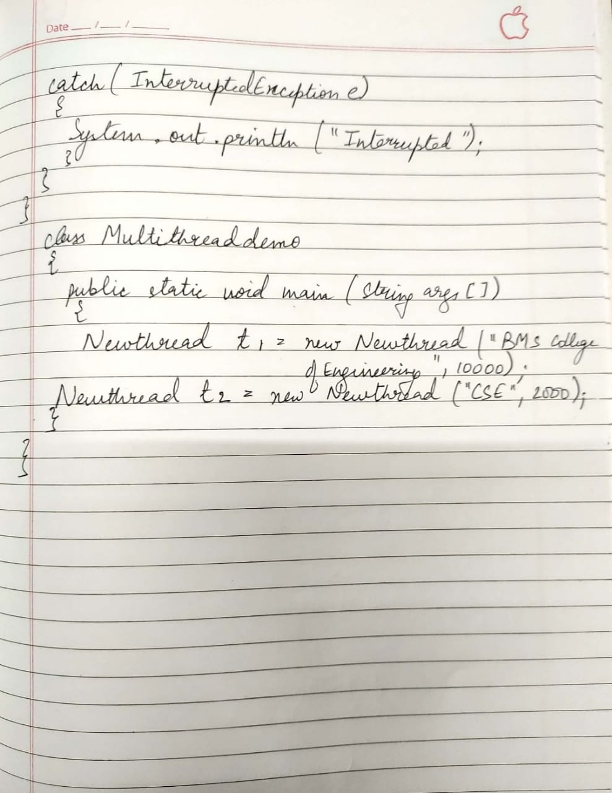

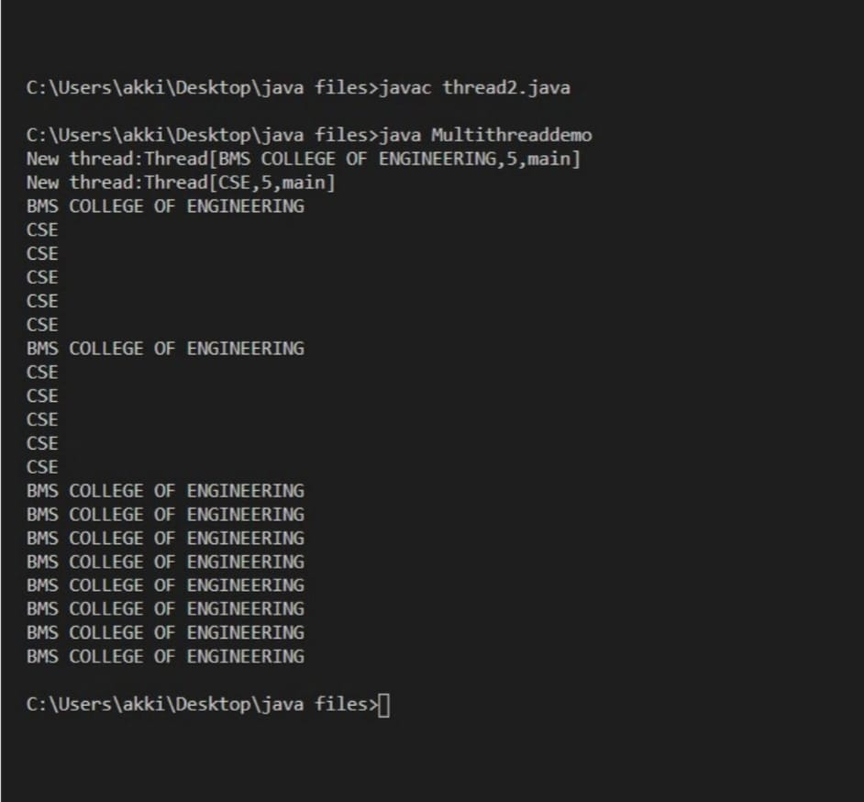

LAB PROGRAM 10: Write a program that creates a user interface to perform integer divisions. The user enters two numbers in the text fields, Num1 and Num2. The division of Num1 and Num2 is displayed in the Result field when the Divide button is clicked. If Num1 or Num2 were not an integer, the program would throw a NumberFormatException. If Num2 were Zero, the program would throw an Arithmetic Exception Display the exception in a message dialog box.

